Potential Analysis of Agricultural Sector in East Java with Klassen Typology Approach Method and LQ (Location Quotient) 2014-2017

Departement of Economic Development, Universitas Negeri Malang, Malang
* Correspondence: oktarsky17@gmail.com
Abstract: The agricultural sector is a sector that supports the lives of most Indonesians. Therefore, the agricultural sector in Indonesia needs to continue to be developed in line with population growth and technological advancements to increase agricultural production. The production of agricultural products plays an important role in development, especially to meet domestic food consumption and also increase export income in Indonesia. Also, the agricultural sector is strategic in the structure of national economic development. Therefore, this research discusses the analysis of typology class and LQ analysis which is used as a reference in the development of the agricultural sector in East Java so that it can play a maximum role in increasing the GRDP of East Java in particular and the National GDP in general.

Keywords: agriculture, development, economic development.
JEL: Agriculture

1. INTRODUCTION
Agriculture is an activity of utilizing natural or biological resources carried out by humans to produce food, industrial raw materials, or energy sources, as well as to manage the environment. The activity of utilizing biological resources included in agriculture is commonly understood by people as plant cultivation or farming as well as livestock cultivation activities, besides that there is also an activity of managing plant waste to be used as fertilizer is one of the activities in the agricultural sector. The agricultural sector includes the food crops sub-sector, the horticulture sub-sector, the fisheries sub-sector, the livestock sub-sector, and the forestry sub-sector. Agriculture is one of the most dominant sectors in increasing people's income in Indonesia because the majority of Indonesians work as farmers.
Indonesia is known as a maritime as well as an agricultural country. Where is agrarian, which means a country that relies on the agricultural sector both as a source of livelihood and as a support for development? This is because the agricultural and plantation sectors are known to be very abundant. Besides, Indonesia can also increase foreign exchange through exports and economic income through the agricultural sector, and become the life support for the Indonesian people, especially farmers. Because Indonesia is superior in the agricultural sector, many regions in Indonesia have become rice granaries for Indonesia. Currently, the majority of farmers in Indonesia still use manual tools in cultivating agricultural land. Seeing the current development with the imbalance that occurs in the agricultural sector is one example of uneven economic development. Economic development is one of the benchmarks to show the economic development of a region, in other words, economic growth can show economic development (Sukirno, Sadono; 2007).
Agricultural development in Indonesia is considered important from the overall national development in supporting the improvement of the economy considering that Indonesia is an agricultural country where most of the population works as farmers. Several things that underlie agricultural development in Indonesia have an important role, among others; Indonesia's large and diverse natural resource potential, a fairly large share of national per capita income, a large share of international exports, the large population of Indonesia who depends on the agricultural sector, its role in domestic food supply (the community) and become the basis for economic growth in rural. Indonesia's agricultural potential is great, but until now, most of our farmers are still poor and lacking in knowledge. This indicates that the government is not empowering farmers but also the whole agricultural sector.
The contribution of agriculture to economic development (Todaro, 2011), namely; agriculture as an absorber of labor, contribution to income, contribution in the provision of food, agriculture as a provider of raw materials, contribution in the form of capital. Through this conception, it is expected that the agricultural sector will be able to grow and improve the economy, so that in turn it can become a new source of growth for the Indonesian economy, especially in terms of achieving the welfare of the farming community, providing jobs, as a vehicle for equitable development between regions, an input and output market. For the agro-industry, generate foreign exchange with exports, increase national income, preserve natural resources, and the environment.
As we know, agriculture is a basic sector in National GDP. East Java Province is no exception, agriculture is also one of the basic sectors in 17 economic sectors in GDP. East Java has 38 regencies/cities where most of the agricultural sector is also the base sector. The reality shows that the agricultural sector plays an important role in its contribution to gross domestic product. The growth rate of the agricultural sector is important with the growth of other economic sectors. It's just that the contribution of the agricultural sector to the gross domestic product from year to year is decreasing in line with technological developments and the rapid development of which causes less land for farming. Furthermore, if we look at the decline in the contribution of the agricultural sector to the gross domestic product of each country, of course, it is different, on the one hand, it will be very dependent on the growth of the agricultural sector and on the other hand, it will be very dependent on other sectors, then clearly this condition will illustrate The relative position of the agricultural sector will decline, both in terms of the structure of the gross domestic product and employment opportunities. This is supported by Kuznet's (1966) opinion which divides the role of the sector into several parts in economic development, namely: (1) product contribution (2) market contribution, and (3) factor contribution. Regeneration and sustainable development are needed using digitization and methods in agriculture, to make time, cost, energy effective, and also increase productivity which can also increase profits received by farmers so that in this case the acceleration of agricultural growth can be achieved, among others by triggering growth centers (growth poles) Which will encourage the growth of other agricultural subsects because it is usually difficult for the sectors to develop.
However, agricultural productivity is still far from expectations. One of the factors causing the lack of productivity in the agricultural sector is the low human resources in cultivating agricultural land and its products. None other than in terms of science and practice in the field which are often not maximal in their application. Development is not only shown by the achievements of economic growth achieved by a sector, but more than that development has a broader perspective. The sector dimension that is often neglected in the economic growth approach has got a strategic place in the development.
The growth center is needed as an incentive for the growth of other sectors. Therefore, LQ (Location Quotient) analysis and Klassen Typology are used to determine the commodities that have advantages in each sub-sector so that they can become a reference in encouraging improvement in quality and quantity which is lacking and developing sub-sector based categories. The main role of the agricultural sector in the development of a country's economy is growing in the agricultural sector itself.
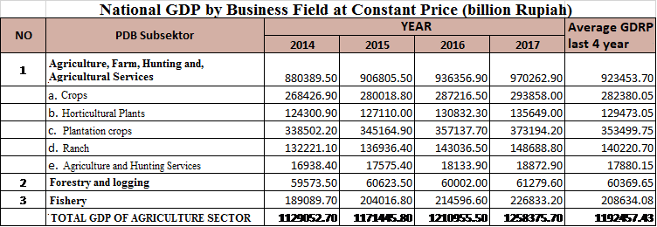
Table 1. National GDP
Source :(BPS.go.id, 2020)

Table 2. East Java GDRP
Average GRDP last 4 Year
YEAR
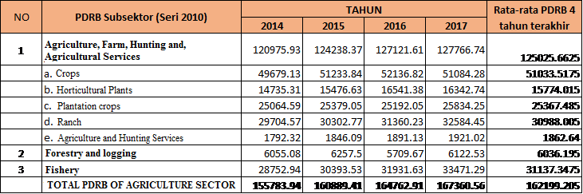
Source : (BPS.go.id, 2020)

Table 3. Economic Growth East Java Province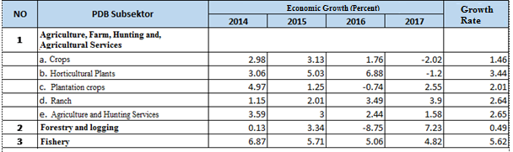Source : (BPS.go.id, 2020)

2. LITERATURE REVIEW
- Agriculture

Agriculture is an activity carried out by humans on certain land, in the relation between humans and land which is accompanied by certain considerations (Suratiyah in Khaafidh, 2006).

The definition of agriculture in the narrow sense only includes agriculture as the cultivation of food crops, whereas if we look further, agricultural activities can produce plants and livestock for the sake of fulfilling the needs of human life. Meanwhile, the definition of agriculture, which is a broad sense does not only include plant cultivation but also cultivates and manages the livestock sector, such as caring for and cultivating livestock that is useful for meeting the needs of many communities, such as chickens, ducks, geese. As well as the use of animals that can help the tasks of farmers, this activity is a scope in the agricultural sector (Bukhori, 2014).

According to the Central Statistics Agency or Badan Pusat Statistik (BPS) Indonesia, the agricultural sector includes all entrepreneurs obtained from nature and constituting biological (living) objects or goods. Included in the agricultural sector are:
- Crops

The food crops sub-sector includes all economic activities that produce food commodities such as rice, corn, cassava, sweet potatoes, sweet potatoes, peanuts, soybeans, vegetables, fruits, grains, and foodstuffs. other.
- Plantation Plants

The plantation sub-sector includes all types of economic activities for plantation crops cultivated by both the people and the plantation companies. The commodities produced include cloves, ginger, cashew nuts, jatropha, cocoa, rubber, kappas, kapok, cinnamon, coconut, oil palm, hazelnut, quinine, coffee, pepper, nutmeg, vanilla, sack fiber, sugar cane, tobacco, and plants. other.
- Ranch

The livestock sub-sector and its products include all activities of breeding and cultivation of all types of livestock and ungag to be bred, raised, slaughtered, and harvested by the people and by livestock companies. Animal husbandry products include; cows, buffalo, goats, pigs, horses, chickens, ducks, chicken eggs, duck eggs, cow's milk, skins, and other pets.
- Forestry and Logging

The forestry sub-sector includes logging of all types of wood and taking leaves, gums, and roots, including hunting. Forestry products include logs (both from the jungle and cultivated forests), firewood, rattan, charcoal, bamboo, turpentine, gondorukem, copal, deer, wild boar, honey water, and other forest products.
- Fishery

The fisheries sub-sector includes all activities of catching, hatching, and cultivating all types of fish and other aquatic biota both in fresh and saltwater. Commodities of fishery products include tuna and other types of sea fish, goldfish, and other types of land fish, milkfish, and other types of brackish fish, squid, and other types of soft animals, seaweed and other types of marine plants.
- Economic growth

According to Sadono (2000), "a tool to measure the success of a region's economy is the economic growth of the region itself." The regional economy will experience an increase from year to year due to the addition of production factors. In addition to production factors, the number of workforce working will also increase from year to year so that if it is maximally utilized it will increase economic growth.

Economic growth is a process of increasing per capita output in the long run. The emphasis is on three aspects, namely; process, per capita output and long term. Each aspect has a different emphasis (Boediono, 2009).
- Growth is a process, not a picture of a moment. In this case, it can be perceived regarding the dynamic aspects of an economy, namely how an economy develops or changes periodically. The emphasis is on change or development itself.
- Output per capita, in this case, two sides need to be considered, namely the total output side or the Gross Domestic Product and the population side. Based on these two crucial points, the process of increasing per capita output must be analyzed by observing changes or movements in total output on the one hand and the population on the other.
- Economic growth contains a long-term perspective. An economy is suggested to have experienced growth if in a long enough time the output per capita has increased. If during such an extended period the per capita output shows a marked tendency to increase, then it can be said that economic growth has occurred.

Achieving high levels of economic growth is one of the four key objectives of macroeconomic policy. GDP is a measure of the market value of output in the form of goods and services produced by production factors, including land, labor, and capital produced by a country in a certain period (Case and Fair, 2004).

3. METHOD

The basic method used in this research is a descriptive-analytical research method, which tells about solving the existing problems based on the data. Data are presented, analyzed, and then interpreted (Narbuko and Achmadi, 1997: 44).

The data used are data according to East Java's GRDP data according to 2014-2017 constant prices, 2014-2017 National GDP includes added value to the agricultural sector and subsector contained in BPS data. Constant price data is GRDP data measured from the base price of the previous years so that the inflation factor can be eliminated. The data analysis in this study using analytical methods typology Klassen and LQ (Location Quotient).
  - Klassen Typology Analysis

Klassen Typology analysis tool is used to find an overview of the patterns and structures of economic growth in each region. Typology Klassen divides regions based on two key indicators, namely regional economic growth and regional per capita income. By determining the average economic growth as the vertical axis and the average per capita income as the horizontal axis, the observed area can be divided into four quadrants, namely:
- Quadrant I : high growth and high income
- Quadrant II : high income but low growth
- Quadrant III : high growth but low income
- Quadrant IV : low growth and low income

(Syafrizal, 1997: 27-38; Kuncoro, 1993: Hill, 1989).

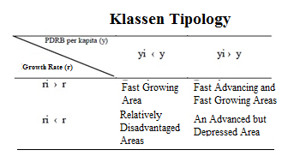

Keterangan :
- ri = district / city GRDP growth rate i
- r = East Java's total GRDP growth rate
- yi = district / city per capita income i
- y = East Java's per capita income

  - Location Quotient (LQ)

The next method is Location Quotient Analysis (LQ), which is a comparison of the size of the role of a sector/industry in a region to the size of the role of the sector nationally. With the location question (LQ) analysis tool, the leading economic sectors in each sector/subsector can be identified. (Tarigan, 2015)

The formulations of the analysis technique are

$$LQ=\frac{Xr/RVr}{Xn/RVn}$$

Keterangan:
- LQ = Location Quotient
- Xr = Contribution of sector i of the study area k (district / city) in the formation of the Real Regional Domestic Product of the study area.
- RVr = Total Real Regional Domestic Product in all sectors of the study area.
- Xn = Contribution of sector i to reference areas (provincial corridors) in the formation of Real Regional Domestic Products of reference areas.
- RVn = Total Real Regional Domestic Product in all sectors of the reference area.

The higher the LQ value of a sector, the more competitive the region's competitive advantage is in developing the sector. From the calculation results obtained, three categories can be found, namely: If the LQ value is less than or equal to 1, it indicates that the sector is not a leading sector. If the LQ value is greater than 1, it indicates that the sector is a leading sector.

To identify the leading sectors, a combination of Klassen and LQ typology analysis will be used. The subsector which is included in the classification of the fast-growing and developing and supported by several sectors that have the advantage makes it possible to become a mainstay sector. Comparative economic analysis is carried out by combining the results of the Klassen and LQ typology analysis, then determining which corridor has the first, second, third, and fourth rank.

4. RESULTS AND DISCUSSION (Times News Roman 11, capital Bold)
  - Klassen Typology Analysis
In this research, using data obtained from BPS in the form of PDRB data and East Java Economic Growth in 2014 - 2017. In the agricultural sector, data consists of several sub-sectors consisting of food crops, horticultural crops, plantation crops, livestock, hunting, and services. , Forestry and logging, and fisheries. The purpose of this research using Klassen typology analysis this time is to determine which sectors can be developed in an effort to determine development priorities and analyze the comparison between economic sub-sectors so that they can be right on target and evenly distributed in the future sustainable economic development in East Java Province.
As mentioned above, the classification typology basically divides regions based on two main indicators, namely regional economic growth, and regional per capita income, based on the results of calculations comparing East Java's GRDP on the X-axis and East Java Economic Growth on the Y-axis.
It can be seen the pattern of economic growth of each agricultural sub-sector in East Java. The data that is needed when calculating class typology using SPSS 16 is the PDRB data of East Java Province and East Java economic growth.
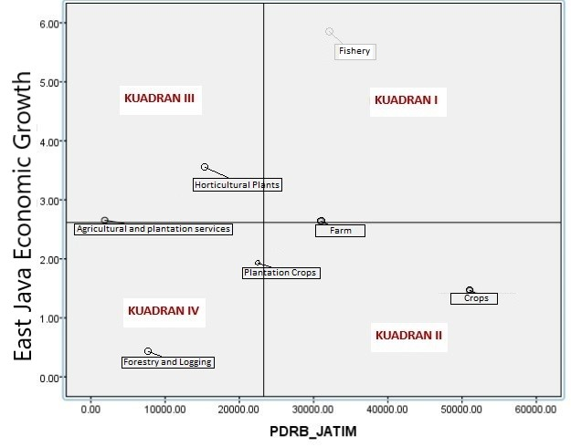
Figure 1. Result of Klassen Typology Analsis
Source: BPS (2020) (Author calculation)

From the output of the SPSS 16 application, it is known:
- Quadrant I, in quadrant I there are fisheries and livestock sub-sectors which are classified as high growth and high income. Besides that livestock is also not included in the first quadrant even though it tends towards quadrant II.
- Quadrant II, in quadrant II, it is known ranch and crops subsectors are included in the high income but low growth trend of the food crop subsector GRDP tends to increase, but there has been a decline in 2017 and is classified as still stable contributing to national GDP / GDP.
- Quadrant III, in quadrant III known that high growth but low income, namely horticultural crops and agricultural and hunting services. Horticulture (garden crops) from year to year the trend of GRDP tends to increase.
- Quadrant IV, it is known that low growth and low income in quadrant IV in the forestry and logging sub-sectors.

  - LQ (Location Quotient)
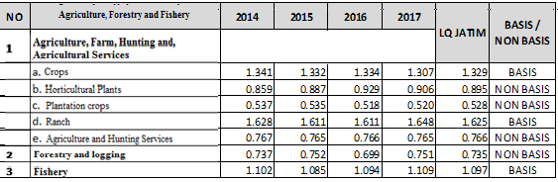
The second analysis is using the LQ (Location Quotient) calculation. The LQ calculation uses 2 data, namely the National GDP and East Java GRDP, where the calculation method has been described in the previous sub-chapter, so the calculation results are as follows :

Figure 2. Result of Location Quotient Analysis
Source: processed

Based on the LQ analysis, it is known that
- Crops have an up and down LQ trend every year, but based on the results of the LQ calculation for 2014 - 2017 amounting to 1,329 so that this sub-sector can be said to represent the base sub-sector in the agricultural sector because LQ> 1.
- Horticultural plants from 2014 - 2017 consider an upward trend, but based on the results of calculations, this sub-sector is not included in the basic sector in the agricultural sector because its LQ value is 0.895.
- Plantation crops from 2014 - 2017 were classified as stagnant growth and the calculation results were included in the non-basis category because LQ <1 was 0.528 and the yield was the lowest compared to other subsectors in agriculture.
- Ranch increased significantly in 2017 compared to 2016, the calculation result is included in the base category because the LQ value> 1 is 1.625.
- Agricultural and hunting services from 2014 - 2017 were classified as stagnant growth and the calculation results were included in the non-basis category because the calculation result of LQ <1 was 0.765.
- Forestry and Logging from 2014 - 2017 were classified as fluctuating growth, and the calculation results were considered non-basis because the value of LQ <1 was 0.751.
- The fishery subsector has an upward growth trend from 2014 - 2017, and the calculation result of LQ> 1 is 1,109 so that the fisheries sub-sector becomes the base sector in the agricultural sector.

  - Policy Analysis
- Crops
Food crops are in quadrant II and are included in the sub-sector basis based on the LQ calculation. Food crops are the main agricultural commodity in East Java, but from year to year, the output of this commodity is decreasing because a lot of rice fields are used for housing. Future land transfers should be noticeabout sustainable development so that fields are not used up as residential land and food security is maintained.
- Horticultural plants
Horticultural plants are in quadrant III and not a base sector, to increase the output and growth of horticultural crops a policy can be made in the form of plant grants, these grants can be started from the lowest line itself, namely the village. Farmers and village communities are given horticultural seedlings to be planted in the surrounding area and when the crops are grown they can be sell so, that the community can get additional income from these plants.
- Plantation crops
Plantation crops are in quadrant II and are not a base sector. Most of the land in East Java is more suitable for growing food crops and horticulture than for plantation crops. There are only a few superior plantation commodities, one of which is sugarcane, the people of East Java can maximize the output of sugarcane to increase the growth of this sub-sector.
- Ranch
Ranch sub-sector is in quadrant I and is the base sector in East Java. It is not surprising that this sector is a basic sector and its annual growth is relatively stable because most of the people of East Java are farmers and breeders. To develop and be stable, the East Java government must be notified about the flow of demand and supply of livestock by minimizing imports if isn't too urgent so that the price of livestock can be stable and the welfare of breeders is guaranteed.
- Agricultural and hunting services
The agricultural and hunting services sub-sector is in quadrant II and isn't a base sector in East Java because agriculture in East Java is mostly still traditional and each farmer tends to own land that is not too large, therefore to maximize their profit many cultivate their land. Without using this service, besides, hunting in East Java is also rare because most farmers prefer livestock to hunt.However, agricultural services have increased in output from year to year because the development of technology also affects the demand for digitalization and methods in agriculture to be able to streamline time, costs, energy and also increase productivity so that agricultural services are needed in this era of industrial revolution 4.0.
- Forestry and Logging
The forestry and logging subsector is in quadrant IV and is not a base sector, although the forest area in East Java is around 42% only 14% used as a community forest. To increase output, the government can lend state forests to be planted by the community, besides that the private sector can also work together to process forest products, but on the condition that the community and investors must prioritize forest sustainability by selective cutting and reforestation.

- Fishery
The fisheries sector is in quadrant I and is the base sector in East Java, with relatively high growth and relatively large output. As we know, in 2014 there were many breakthroughs made by the new Minister of Marine Affairs and Fisheries, such as prohibition about the export of lobster seeds, a prohibition about fishing by foreign vessels, and many other policies. With these breakthroughs and new policy, the fisheries sub-sector in East Java can be called advanced and proven by the increase in yields from fisheries

5. CONCLUSION AND SUGGESTION

CONCLUSION
Based on the analysis of classical typology in the four quadrants of the agricultural sector, including the fast-growing and fast-growing sub-sector, is the fisheries and livestock sub-sector. Classified as advanced but depressed sub-sectors are the estate crops and food crops sub-sector. The fast-growing sub-sector is horticultural crops and agricultural and hunting services, and the agricultural sub-sector that is relatively lagging is the forestry and logging sub-sectors. With the analysis of classic typology, we can find out which sectors need extra attention because their development is relatively depressed, and which sectors are already good and must be maintained.
Meanwhile, the results of the LQ analysis show that the growth rate is fluctuating but still relatively stable. The leading sub-sector / base sub-sector in this agricultural sector is the livestock sub-sector followed by food crops and fisheries. Furthermore, in the calculation of LQ, the non-base subsector in the agricultural sector is horticultural crops, plantation crops, agricultural and hunting services, forestry, and logging.
So that in determining development policies and sectoral development, in this case, the agricultural sector, it is necessary to synchronize between sub-sectors so that there is continuity so that sub-sectors that tend to be still depressed can be appointed by other sectors so that per capita income also increases.
SUGGESTION
All sub-sectors in agriculture must still receive proportional attention by their potential and development opportunities to create inter-subsector sustainability, in this case, the agricultural sector, to optimize output so that farmers in particular, can prosper and increase GDP in general. So that the role of the government as a policymaker must also side with the welfare of farmers not only for a few groups. The community also takes part in the development of this agricultural sector by being critical of existing policies and continuing to innovate in developing the agricultural sector so that East Java agriculture can implement sustainable economic development.

REFERENCE
Androsova, I. V., Melnichuk, A. V., Bondaletov, V. V., Vinichenko, M. V., & Duplij, E. V. (2016). On the issue of state support of agriculture: Regional aspect. International Journal of Economics and Financial Issues, 6(1S).

Badan Pusat Statistik. (2017). Statistik Indonesia 2017.bps.go.id.

Badan Pusat Statistik. (2017). Provinsi Jawa Timur Dalam Angka 2017.jatim.bps.go.id.

Kuncoro, M. (2010). Dasar-dasar Ekonomika Pembangunan. Yogyakarta: UPP STIM YKPN.
Sukirno, S. (2004). Makroekonomi teori pengantar. Jakarta: PT Raja Grafindo Perkasa.
Rahayu, E. S. (2010). Aplikasi Tipologi Klassen pada Strategi Pengembangan Sub Sektor Pertanian Tanaman Pangan di Kabupaten Boyolali. Journal of Rural and Development, 1(2).

World Bank. (2017). World Development Indicators 2018. https://doi.org/CC BY 3.0 IGO

Isbah, U., & Iyan, R. Y. (2016). Analisis peran sektor pertanian dalam perekonomian dan kesempatan kerja di Provinsi Riau. Jurnal Sosial Ekonomi Pembangunan, 7(19), 45-54.

Tarigan, Robinson. (2015). Ekonomi Regional Teori dan Aplikasi. Jakarta: Bumi Aksara.
Tarigan, Robinson. (2016). Perencanaan Pembangunan Wilayah. Jakarta: Bumi Aksara.
Winoto, J., & Siregar, H. (2016). Agricultural development in Indonesia: current problems, issues, and policies. Analisis Kebijakan Pertanian, 6(1), 11-36.

Sukirno, S. (2004). Makroekonomi teori pengantar. Jakarta: PT Raja Grafindo Perkasa.
Wicaksono, I. A. (2011). Analisis Location Quotient Sektor Dan Subsektor Pertanian Pada Kecamatan Di Kabupaten Purworejo The Analysis of Location Quotient on Sector and Subsector of Agriculture among the Sub Districts in Purworejo Regency. Mediagro, 7(2).

